
NAME: M NASEEM
ROLL NO: 055
SECTION: BSSE-4A
SUBJECT: AI(lab)
SUBMITTED TO: RASIKH ALI

Reorder Branches and Observe How Pruning Changes
Objective: To understand how changing the order of branches affects Alpha-Beta Pruning while keeping the optimal Minimax value unchanged.
Step 1: Original Leaf Values
The original leaf values are:
python
[3, 5, 2, 9, 0, 7, 0, 0]
Step 2: Reorder the Branches
Now, change the order of the last four leaf values:
python
[3, 5, 2, 9, 0, 0, 7, 0]
This changes the order in which the algorithm explores the branches.
Step 3: Run Both Algorithms
Use the same Minimax and Alpha-Beta functions from Task 2. Only change the scores list and reset both counters before running the algorithms.
Step 4: Compare the Results
Algorithm | Original order | Reordered order
Minimax evaluated leaves | 8 | 8
Alpha-Beta evaluated leaves | 8 | 6
Optimal value | 5 | 5
Same optimal value
Step 5: Conclusion
I changed the order of the branches and tested both algorithms again. Minimax evaluated all 8 leaves, while Alpha-Beta evaluated only 6 leaves after reordering. Both algorithms returned the same optimal value of 5. This shows that good move ordering helps Alpha-Beta Pruning reduce unnecessary calculations.

Step 6: Evidence
CODE:
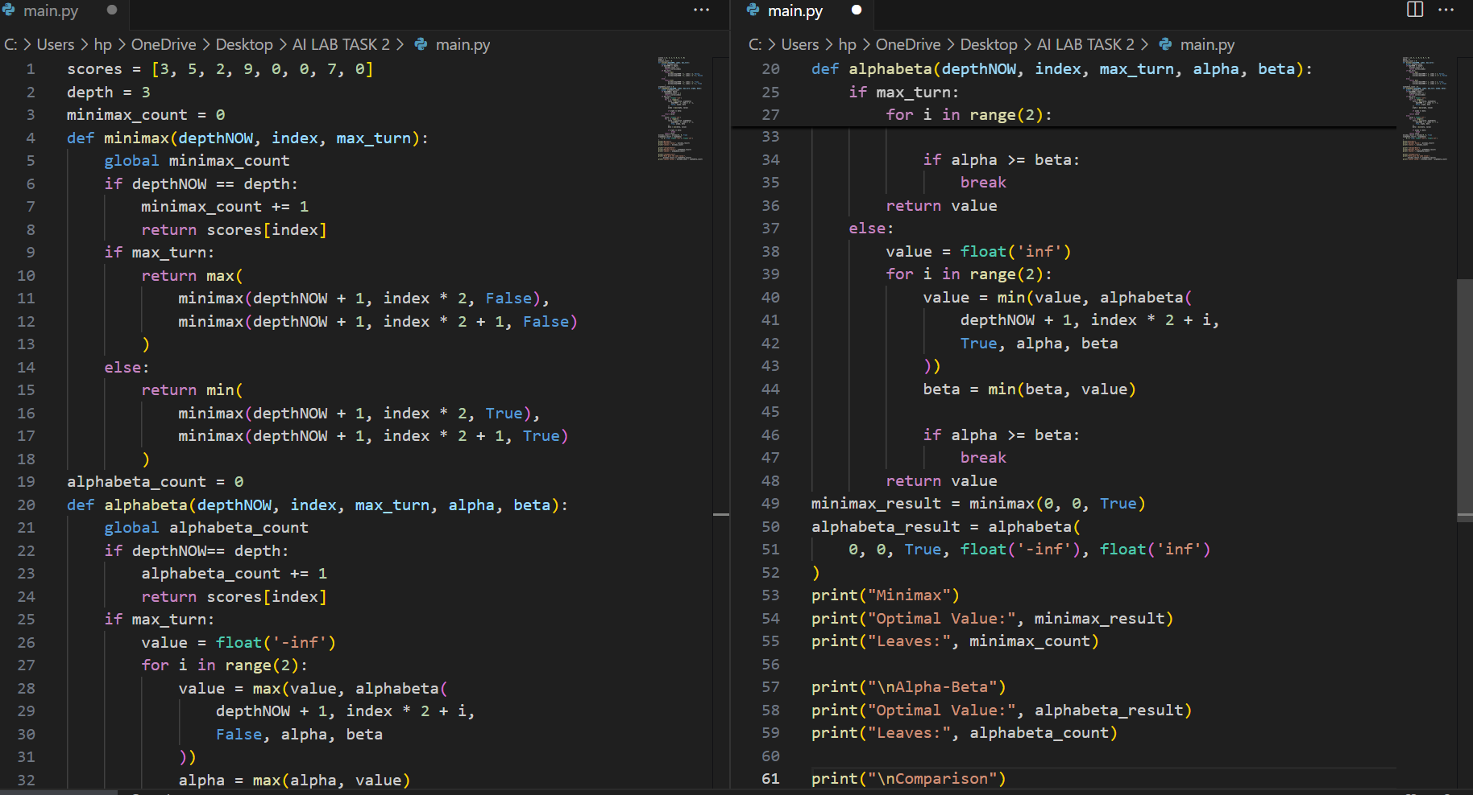
OUTPUT:


